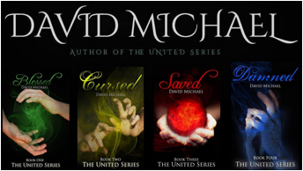

NEW RELEASE
Damned
Book four
The United Series
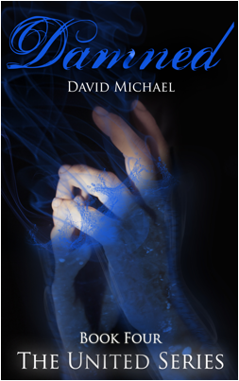

About the book

Strapped with the weight of being a favorite of one of the sisters of Fate, Hayden struggles to find his place in the world.

When he finds himself being hunted by two vengeful Archangels, he must learn to rely on four strangers who he knows next to nothing about.

Hayden, Luke, Sarah, Makkar, and the mysterious Kane must learn to overcome their differences, which span lifetimes, and work together if they want to survive the onslaught of divine retribution constantly raining down around them.

With the lines between right and wrong blurred so far and both sides willing to break all the rules, this is humanity’s last chance to come out of this battle on top or be destroyed by a holy war that was never meant to be ours to fight.

There are no more sides to be taken.

It’s time to stand and fight.

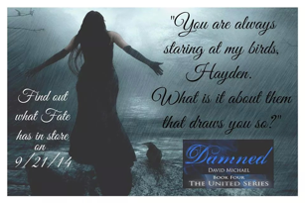

Available exclusively on
Amazon
Through 12/21/2014

The rest of the series is available on

Amazon Barnes & Noble Kobo
iBooks Page Foundry Scribd
CreateSpace

About the author

David Michael, author of The United Series, is a self-proclaimed crazy cat lady, a hater of snow, a lover of Star Trek and has an addiction to coffee that is excessive even for an author.

He lives in Salt Lake City where he is currently majoring in Psychology, working a "big boy" job, and writing full time. He shares a living space with his best friend, idolizes his mother, and has a strange knack for making friends with people on the other side of the planet instead of his own back yard.

Wanna stalk him?

Facebook Twitter Goodreads
Google + Wordpress

